PROJECT SYNOPSIS

**1.1 Title of The Project:**

"KOGO – TRANSLATING KONKANI ON THE GO"

**1.2 Abstract**

When you visit the Konkan regions of the Indian subcontinent, whether it’s for business or for a holiday, communicating with the Konkan crowd without knowing the language can be a real hassle. This is where KOGO comes in.

With KOGO’s enhanced and everyday developing tool, you can now translate with ease. Translate Konkani to English and the other way around with our tool starting today!

**1.3 Objective of The Project**

The project titled "KOGO – Translating Konkani on the go" intends to provide a website for effective translation between Konkani and English. It consists of all the tools required to help the user with translation. Our advanced translation tool can help in simplifying complex translations.

The main objectives of project KOGO are:

* Designing the translator tool keeping in mind the User Experience (UX) the target audience is familiar with.
* To provide access to resources that can further help the user excel in Konkani.
* Establishing a forum – a community where users can build connections, read FAQs, and have discussions on the platform.

**1.4 Project Category**

It is a Web-based Translation tool.

**1.5 Language to Be Used**

Front-end: HTML, CSS, JavaScript

Back-end: PHP, MySQL

Processor: XAMPP V3.3.0

Browser: Any browser

**1.6 Structure of The Proposed Project**

The main intention of project "KOGO" is to continually provide seamless translations between English and Konkani to users. This project has a Web-based approach. The structure described below is what’s planned at the moment to undergo further development

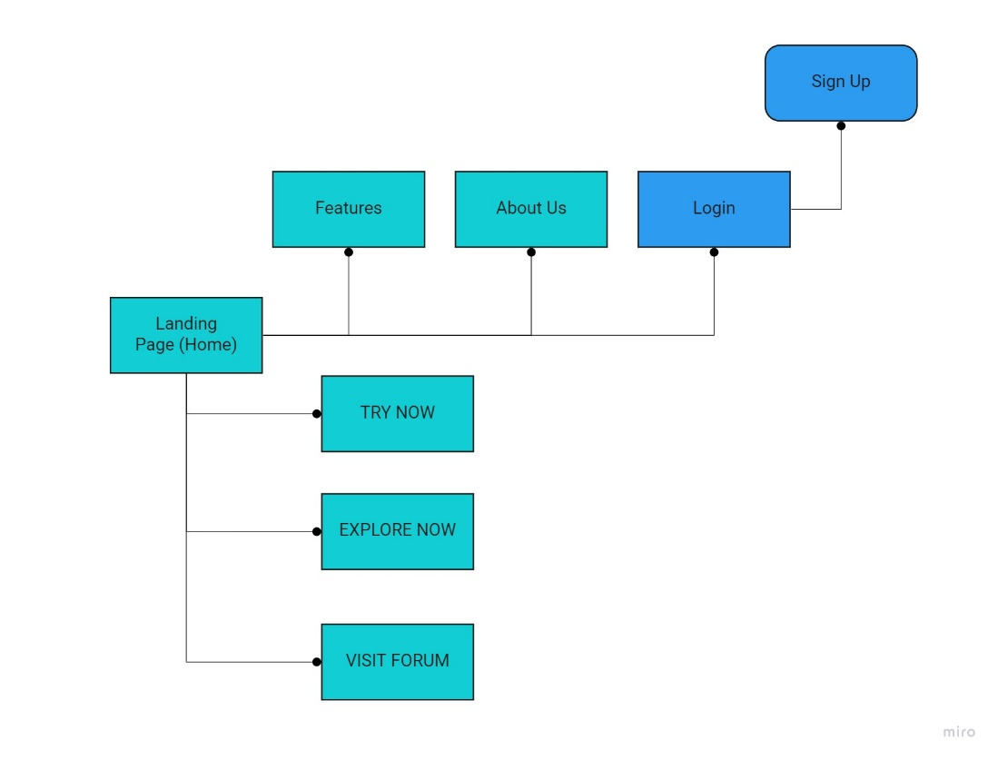

**1.7 Module Description**

There are 3 interfaces present and they are –

Home, Features, About Us and Login

Home

Be captivated by content, not clutter. Home is considered to be the main screen where all the main highlighted features of the project will be present.

Features

A page that describes the services of what our project can do

About Us

This page will present the vision of the team behind KOGO.

Login

The best practices for our login screen are (in no particular order) is:

* To simplify registrations
* Allow login via external accounts
* Go for email instead of usernames
* Facilitate password resetting
* Keep users logged in

By following these best practices, Our login screen starts building an amazing user experience right from the first screen, which will do wonders for user retention, as well.

**1.8 Future Scope of The Project**

Home: This page gives the users access to three pages – The Translator, Resources, and the Forum.

Login: This will allow the users to log in to the platform

Features: This page will provide the users with a brief about the prospects of project “KOGO”.

About Us: This page will present the vision of the team behind KOGO.

The website will have timely updates to stay relevant and to resolve bugs in the system. Facility for a more interactive interface will be developed over time by gathering customer feedbacks and working on improving along the lines. Securing the ‘Login’ and ‘Sign Up’ details to establish a reliable platform that upholds strong privacy principles is included in the primary focus of the project.

**1.9 Bibliography**

1. <https://groups.google.com/g/goa-book-club/c/RWprxDyQlg4?pli=1>
2. <https://www.goaholidayhomes.com/information/learn-konkani.html>
3. <https://www.shabdkosh.com/dictionary/english-konkani/>

**SOFTWARE REQUIREMENTS AND SPECIFICATIONS**

**INTRODUCTION**

A Software Requirement Specification is a document that describes the nature of the project. The aim of this document is to gather, analyze, and give in-depth insight of complete “KOGO”- Konkani translation by defining project in detail. The basic purpose of SRS is to bridge the communication gap between the parties involved in the development of the software. SRS is a medium through which the client and user needs are accurately specified. A good SRS should satisfy all the parties- something very hard to achieve- and involves trade-offs and persuasion. Another important purpose of developing an SRS is helping the users understand their own needs.

**The main advantages of SRS are:**

It establishes the basis of agreement between the user and the supplier on what the software product will do. It provides a reference for validation of the final product.

**Purpose**

The purpose of this SRS document is to provide a detailed insight of our product “KOGO- Konkani On Go”, its parameters and its goals. It will illustrate the purpose and complete declaration for the development of the system.

**Scope**

The scope of the project from admin side is, it allows admin to manage the words by adding new words and grammar, discuss on words with the registered users by text comments.

The scope of the project from user side is, it allows user to translate English words to Konkani words.

The scope of the project from registered user side is, it allows registered user to login, translate the words from English to Konkani, registered user can add new words, they can discuss on new words.

**Definitions, acronyms, abbreviations**

**SRS :** Software Requirement Specifications.

**CSS :** Cascading style sheet

**SQL :** Structured Query Language.

**ADMIN:** the Administrators

**PHP** **:** Hypertext Pre-Processor

**HTML :** Hypertext mark-up language

**Overview**

The “KOGO” is designed to provide user with an easy-to-use website which makes the process of learning and understanding Konkani much easier. The system is designed to provide the user with systematically access to understand the Konkani language, add new words which are not available in the website.

**OVERALL DESCRIPTION**

**Product Perspective**

“KOGO” system is a web application which includes 2 phases where the first is intended to be used by admin and user. The user can login to the web application then the registered user can add new words to the web application, even admin can add new words, grammar and approve the new words given by the registered user to the web application.

The registered user has a unique id, which serves as authorization ID. The authorization ID gives authorization to add new words.

The second phase is intended to provide a platform to the user to translate language form English to Konkani. To translate, the user doesn’t need to be logged in.

**Product Functions**

**Admin**

Admin Logs in

Manages Words (add news word, grammar)

Discuss on new words

Admin Logs out

**User**

Word Translation

**Registered User**

UserLogs in

Word Translation

Adds new words

Discuss On words

User Logs out

**User Characteristics**

**Admin**

Admin will be provided full provision to the system. Admin will have the responsibility to check the new words which the user has suggested, approve those words, even admin can add new words, grammar. Admin can discuss on the new words suggested by the registered user through the text comments.

**User**

The user can only translate words from English to Konkani.

**Registered User**

The registered user can login, can translate form English to Konkani, add new words, and can discuss on the new words in the text comments.

**General Constraints**

The constraints, rule, and regulations to be followed in developing the website:

* Hardware limitations.
* Internet connection.

**Assumptions and Dependencies**

* Since this is a web application, it is dependent on both the user and admin having internet connection to use the application.

**SPECIFIC REQUIREMENTS**

**External Interface Requirements**

* **User Interfaces**
* **Hardware Interfaces**
* **Software Interfaces**

**User Interface**

The web application provides good graphical interface for the front end can make use of the system with ease.

We have taken following requirements during design

* Textboxes to enter words.
* Submit Buttons to submit words.
* Labels to give the translation.

.

**Hardware Interface**

There is no special hardware required.

**Software Interface**

* The software requires the support of the following software for the database and other

requirements.

* PHP for the front end.
* Xampp for database.

**Communication Interfaces**

This is a web-based system and communication is done with through internet and internet protocol.

**FUNCTIONAL REQUIREMENTS**

**Guest User**

**Function:** The guest user page will get a translation box to translate words.

**Input:** Translation word

**Output:** Translated word.

**Registered user**

**Translation:** Translates words from English to Konkani.

**Login:** Allows the user to login to the website.

**Add Words:** This allows the registered user to add new words which are not available in the website.

**Discuss on words:** This allows the registered user to discuss about new words added by same user or the other users through text comments.

**Admin:**

**Login:** Allows admin to login.

**Add Words:** Admin can add words new words, grammar to the website database.

**Approve words:** The admin has the authorization to approve words that have been suggested by the registered user.

**Discuss on Words:** Allows the admin to discuss on the new added words by the registered user or the by the admin.

**Performance RequirementS:**

Performance requirements are:

* Translation will be based on the internet connection.
* Works for medium size information databases.
* Should not be overloaded.

**Design Constraints**

The design should not be too technical to be understood by user.

**Other Non-functional Requirements:**

**Performance Requirements:**

The proposed system that we are going to develop will be used as the Web based application for various performenses. Therefore, it is expected that the database would perform functionally all the requirements that are specified by the user.

**System attributes:**

The Quality of the database is maintained in such a way so that it can be very user friendly to all the users of the database.

* **Reliability:** Web based application is to be made quick responsive, hence it stays reliable.
* **Maintainability:** Since application is web based it is much easier to maintain. Any changes in the code will affect all the user.
* **Portability:** Application can be used in desktop, laptop or handheld devices.
* **Flexibility:** Website can be used anywhere and at any time.
* **Reusability:** The codes written once can be used for the next time even if the server changes.

**Other requirements:**

**Safety requirements**

There is always a chance discrepancy and also database can be crashed due to virus therefore it is mandatory to have a database backup.

**Security requirements:**

In this project the admin and registered user has access to most of the major functions and it is necessary that the admin must be authorized, and hence admin and registered user is given with unique ID which is used to access the vast features of the software.

**Context Flow Diagram**

Context flow diagram is a top-level data flow diagram. It only contains one process node that generalizes the function of the entire system in relationship to external entities. In context diagram the entire system is treated as a single process and all its inputs, outputs, sinks and sources are identified and shown.

**LEVEL 0 CFD**

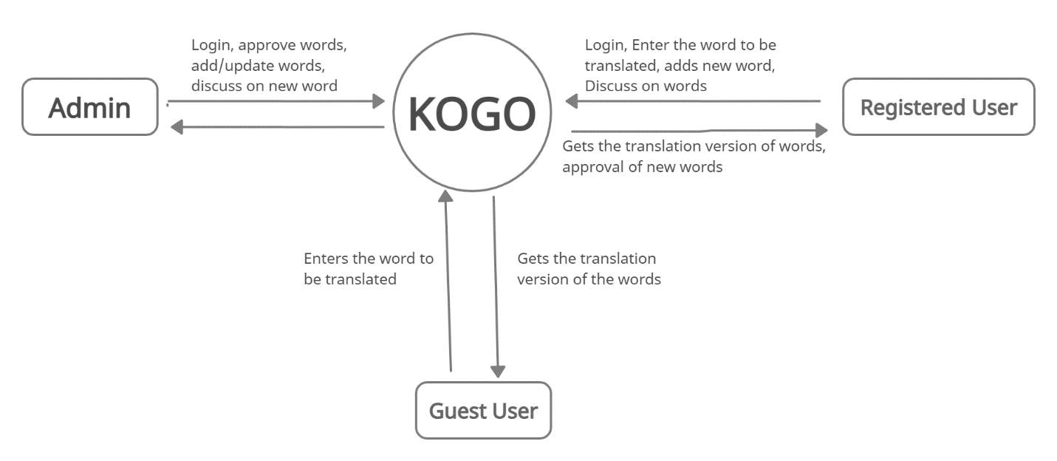

**Data Flow Diagram**

A Data flow diagram is the graphical representation of the of data through an information system, modelling its process aspects. A DFD also known as bubble chart or dataflow graph are commonly used during problem analysis. DFD'S are very useful in understanding a system and can be efficiently used during analysis, A DFD will show what kind of information will be input to and output from the system, how the data will advance through the system, and where the data will be stored it does not show information about process will operate in sequence or in parallel format, A DFD is often used as the preliminary step to create an overview of the system without going into great detail, which can later be elaborated, it can also be used for the visualization of data processing DFD shows the movement of data through different transformations or process in the system.

* The processes are shown by named circles.
* The data flows are requested by named arrows entering and leaving the bubbles.
* The rectangle represents a source or sink and is a net originator or consumer of the data.
* Two horizontally parallel lines represent data store, a data is a place where data is held temporarily from one transaction to the next or is stored permanently.
* A process cannot have outputs.
* A process cannot have only inputs.
* The inputs to a process must be sufficient to produce the outputs from the process.
* All data stores must be connected to at least one process.
* All data stores must be connected to a source or sink.
* A data flow can have only one direction of the flow. Multiple data flows to and from the same process and data store must be shown by separate arrows.
* If the exact same data flows to two separate arrows, it should be represented by a forked arrow.
* Data cannot flow directly back into the process it has just left. All data flows must be named using a noun phrase.

**Level 1 DFD**

**Admin:**

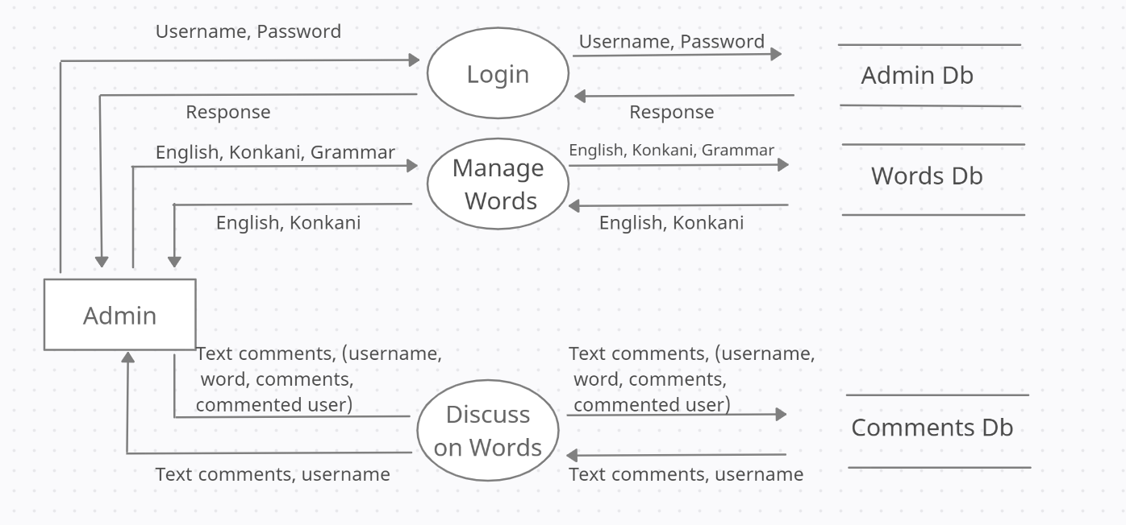

**Level 1 DFD**

**Guest User:**

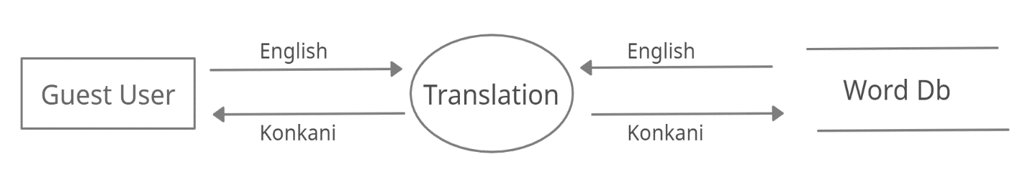

**Level 1 DFD**

**Registered User:**

